

ICIS DMR Plug-In Starter Kit
Installation and Administration Guide

EN-Node

Version: 2.0

May 31, 2012



1368 How Lane
North Brunswick NJ 08902
www.enfotech.com

Restriction on Use and Disclosure of Document Information

This document includes data that should not be disclosed outside the business entity for which it was intended, indicated as the recipient on this title page. The entire document is copyrighted by enfoTech and is protected under the US copyright law and international treaties. No part of this document may be reproduced or transmitted in any form or by any means, electronic or mechanical, for any purpose, without express written permission from enfoTech & Consulting Inc.

Copyright © 2001 – 2012 by enfoTech & Consulting Inc. All Rights Reserved.
Revision History
Version | Date | Created By | Reviewed By | Description
2.0 | 05/31/2012 | Peter Huang | Daniel Jeng

Tables of Contents

1. Document Purpose 4
2. Plug-In Overview 4
3. Supported Schemas and Payloads 5
4. Prerequisites 5
5. Installation Package 5
6. Installation Instruction 5
6.1 Create an ICIS-DMR staging database 5
6.2 Modify ICISOperationConfig.xml 6
6.3 Create an ICIS Domain in the Node Administration Console 7
6.4 Create a solicit web service with the SubmitICISDMR plug-in 7
6.5 Configure SubmitICISDMR plug-in for Operation Manager 8
7. Test ICIS-DMR Plug-In 10
7.1 Access Operation Manager 10
7.2 Call Operation to Generate ICIS-DMR Submission File 10
7.3 Call Operation to Submit ICIS-DMR Data to EPA 11
7.4 Reading Process Report for Validation 11

Document Purpose
The purpose of this document is to provide guidance on the setup, use, and maintenance of the EN-Node ICIS-DMR Plug-in. This plug-in has been modified and upgraded to accommodate ICIS-DMR schema version 2.0. All necessary files and stored procedures contain different names so that it will not have any overlap/conflicts with any existing, older versions of the ICIS-DMR Plug-In. The installation package includes all the necessary files to perform the following sequential steps:
- Create an ICIS-DMR Staging Database with necessary tables, views, and stored procedures.
- Create an ICIS domain in which to group and register ICIS-related operations under.
- Configure the SubmitICISDMR operation under the ICIS domain. The operation will first call a solicit service from your local node and access your ICIS-DMR Staging database to retrieve and generate necessary data in XML format. Once generated, the operation will then zip and submit the file to the EPA.

This document also provides a step-by-step instruction on how to test the plug-in process from beginning to end.

Plug-In Overview
The following diagram outlines the ICIS-DMR plug-in and its interaction with an existing NPDES data management system and EPA.

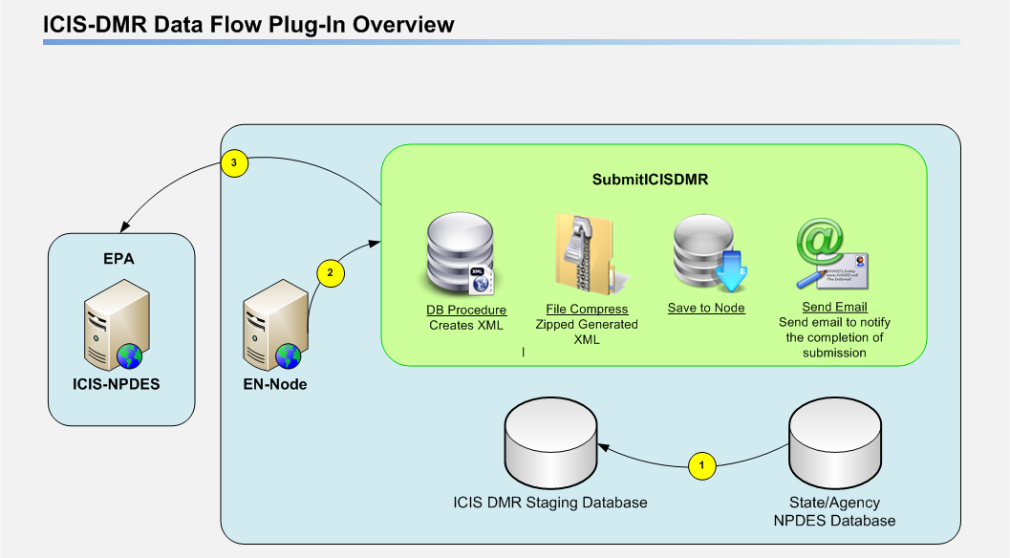
Figure 1: ICIS-DMR Data Flow Plug-Ins Overview

In the following sections and diagram below, the ICIS-DMR Plug-in is described in detail.

1 | The State or Agency will populate the ICIS Staging Database.
2 | The EN-Node Invokes the SubmitICISDMR plug-in though Node Operation Manager. This process includes the following steps:  - The plug-in obtains available ICIS-DMR data from the ICIS staging database.  - The plug-in executes a Database stored procedure component to generate an ICIS DMR XML file.
3 | The plug-in then compresses the XML to a zip file, and submits the result to EPA. The implementation details are described here:  - The XML file generated during the previous step will be compressed and saved to the node database  - An Authenticate web service call will then be invoked with NAAS account information. The NAAS account information is part of the passing parameters to the plug-in.  - If the Authenticate is successfully executed, a valid security token will be obtained.  - A failed attempt of Authentication will end the process and will be logged with a failed status in EN-Node  - The security token and the compressed file are delivered to CDX via a web service Submit call.  - The successful result of the submission is determined by obtaining the transaction id.  - The transaction id will be saved.

Supported Schemas and Payloads
- Schema(s): 2.0
- Payload(s): DischargeMonitoringReportSubmission

Prerequisites
- EN-Node application is installed
- A local ICIS-DMR data source exists in SQL Server format

Installation Package
- ICISDMRStagingDB.zip
- ICIS_STG_v2.sql
- ICIS_OBJ_v2.sql
- ICISOperationConfig.xml

Installation Instruction

Create an ICIS-DMR staging database
Before any ICIS-DMR plug-in installation, users need to verify that an ICIS-DMR staging database is created. To create an ICIS-DMR staging database, please execute the following steps:
- Log in to MS SQL Server as an administrative account.
- Find the ICISNPDESStagingDB.zip file and unzip it.
- Open the file into MS SQL Server.
- Execute ICIS_STG_v2.sql: This script creates the following ICIS staging tables:
- convert_pcs_to_icis
- his_icis_dmr
- icis_dmr_numeric_results
- icis_dmr_report
- icis_dmr_report_data
- icis_dmr_validate_null
Make sure to change the directory within the script to the desired database location (as seen below), then execute ICIS_STG_v2.sql.

CREATE DATABASE [ICIS_STG_S] ON PRIMARY
( NAME = N'ICIS_DMR_STG', FILENAME = N'F:\MSSQL\Data\icis_stg_s.mdf' , SIZE = 132672KB , MAXSIZE = UNLIMITED, FILEGROWTH = 1024KB )
LOG ON
( NAME = N'ICIS_DMR_STG_log', FILENAME = N'F:\MSSQL\Data\icis_stg_s_1.ldf' , SIZE = 35712KB , MAXSIZE = 2048GB , FILEGROWTH = 10%)

*NOTE: If a different ICIS-NPDES related Plug-In (ie. Unpermitted Facility or Inspection) is already configured, you do not need to execute the ICIS_Stage_DB.sql.
- Execute ICIS_OBJ_v2.sql. This script creates all necessary views and stored procedures.
- Upon successful execution of ICIS_STG_v2.sql and ICIS_OBJ_v2.sql, the results will be as follows:
- ICIS-NPDES staging table will be created
- ICIS-NPDES views will be created
- ICIS-NPDES stored procedure will be created

Modify ICISOperationConfig.xml
The ICISOperationConfig.xml is a data wizard configuration file that contains a list of logical steps defining the complete workflow (figure 1) of the plug-in.
- Find the following Section in the ICISOperationConfig.xml

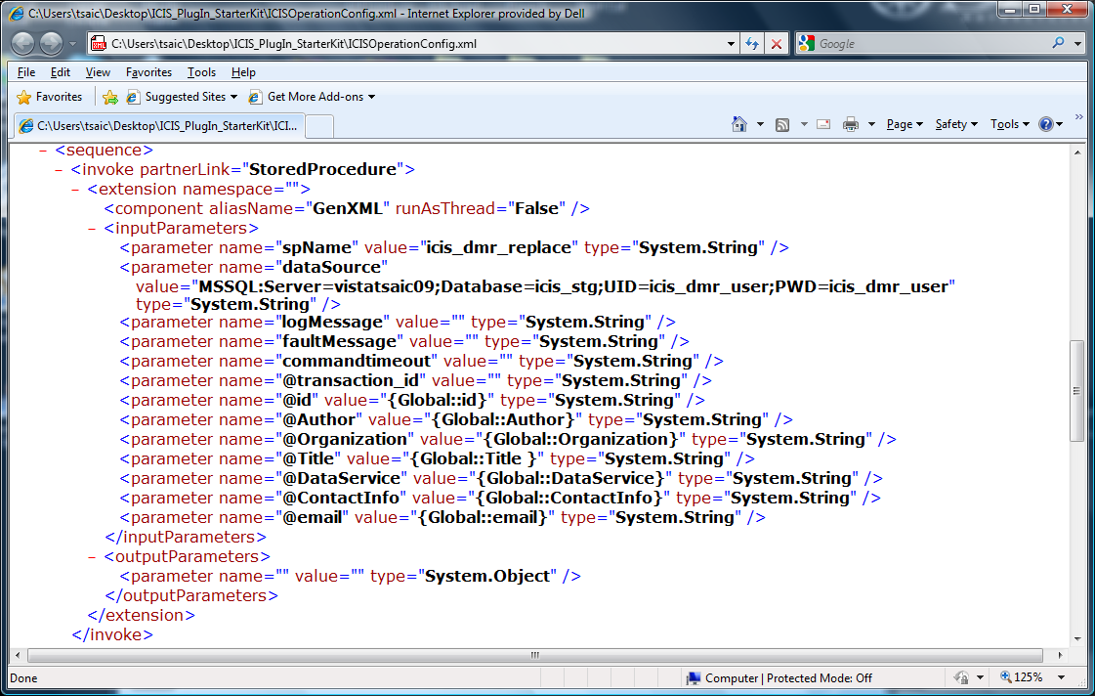

- Modify the value for dataSource to connect to your ICIS-DMR staging database.

Create an ICIS Domain in the Node Administration Console
In order to register an operation using the SubmitICISDMR plug-in under the EN-Node, you must first create a Domain. The Domain is logical grouping of operations. Please execute the following steps:
- Log into the Node.Administration console with the appropriate username and password.
- Click the “New Domain” link under the “Node Domain” Module and fill in the following information:
  - Domain Name: ICIS
  - Domain Administrator: admin (or any other accounts you would like to manage the ICIS file creation process)

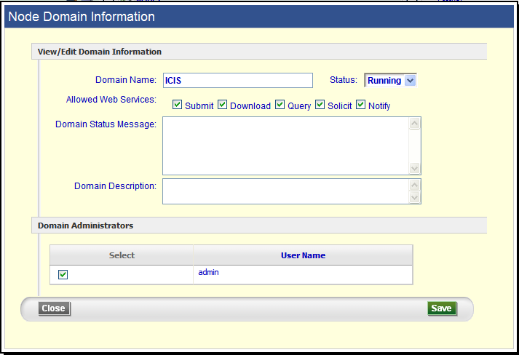
Figure 2: New Domain Information

Create a solicit web service with the SubmitICISDMR plug-in
- Locate the Node Domains webpart from the Node Dashboard.
- Under the Node Domains webpart, click the “Go to Operations” link that corresponds to the ICIS Domain
- Click the “Create Operation by XML” button
- When prompted, locate and upload the ICISOperationConfig.xml file.

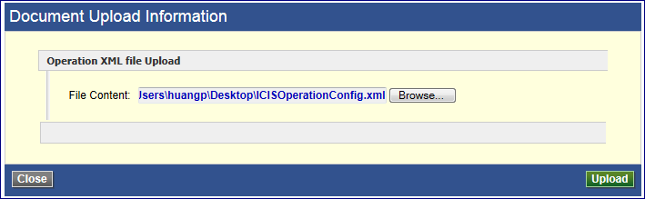
Figure 3: Upload Data Configuration XML File

- Click the “Save” button

Configure SubmitICISDMR plug-in for Operation Manager
- Return to the Node Dashboard screen
- Under the Node Configuration module, click the icon link for “(7) Operation Manager”

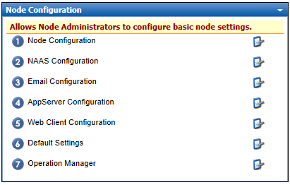
Figure 4: Node Configuration: Operation Manager

- Under the Operation Manager screen click the “Add Operation” button
- Under the Configure Operation section:
  - Select Operation Name = SubmitICISDMR
  - Check Enable GetStatus options
- Under the Submit section
  - Enter in URL as following:
      - https://testngn.epacdxnode.net/ngn-enws20/services/NetworkNode2ServiceConditionalMTOM (for testing endpoint)
      - https://cdxnodengn.epa.gov/ngn-enws20/services/NetworkNode2ServiceConditionalMTOM (for production endpoint)
  - Enter User Name = Enter NAAS assigned User ID
  - Enter Password = Enter NAAS assigned Password
  - Enter Domain Name = default
  - Enter Data Flow Name =ICIS-NPDES
- Under GetStatus section:
  - Completed Status = Completed
  - Failed Status = Failed
  - Click “Save Operation” button
- Refer to screenshot:
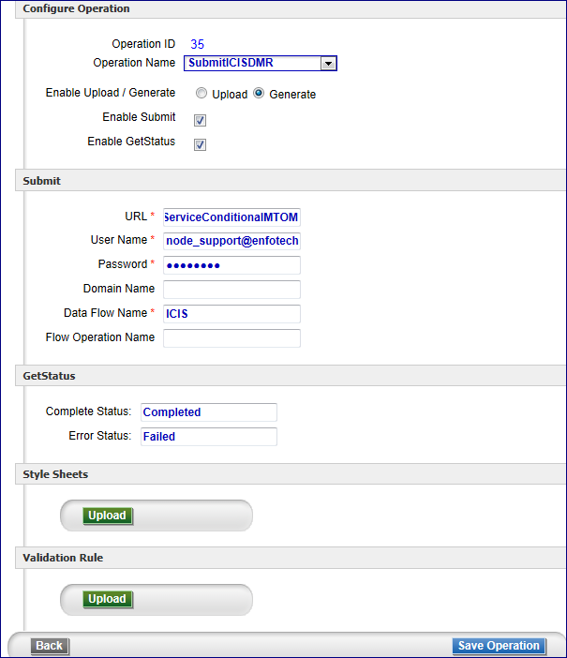
Figure 5: Operation Configuration Page

Test ICIS-DMR Plug-In
If the ICIS-DMR staging database has been successfully populated by a local ICIS-DMR data source from which you will generate ICIS-DMR XML files, please follow the steps below to generate the ICIS-DMR submission file from the ICIS-DMR staging database and submit to EPA:

Access Operation Manager
- First log into the Node Administration application.
- Under the Favorite Links webpart, click the “Operation Manager” link.
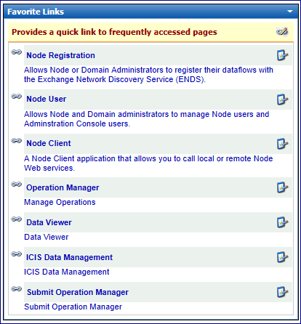
Figure 6: Favorite Links: Operation Manager

Call Operation to Generate ICIS-DMR Submission File
- From the Selected Operation dropdown, select the “SubmitICISDMR” operation.

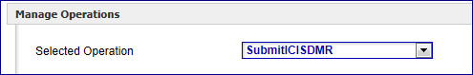
Figure 7: Operation Manager: Selecting Operation

- Click on the “Generate” button to generate the ICIS-DMR XML submission file from the ICIS-DMR staging database.
  - Generation of the ICIS-DMR XML submission file may take some time, so the file may not be available immediately.

Call Operation to Submit ICIS-DMR Data to EPA
- Once the ICIS-DMR XML is generated, you can find it from the data grid.

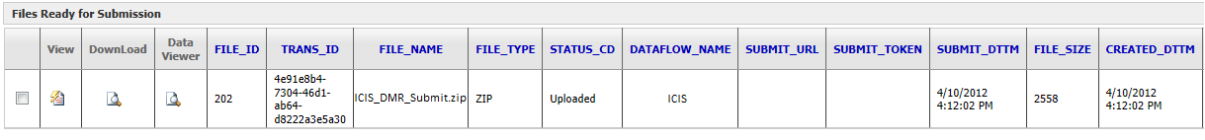
Figure 8: Operation Manager: Operations Detail

- From the grid, check the checkbox for the generated ICIS-DMR Data file.
- Click the “Submit” button to submit the ICIS-DMR file to the EPA CDX Node.
- After the file is submitted to the EPA, the EPA will return the status of either “Completed” or “Failed” back to the user. This status can also be seen in the Operation Manager Gridview.
- To download the process report, click the icon under the DownLoad Column. The following section will guide users on how to read the process report.

Reading Process Report for Validation
The screenshots below will describe a few cases of the downloaded file. First, check the submission-metdata.xml to check whether or not the file has passed or failed the xml schema validation. If the schema has passed, the user should be able to download the retrieved data. If the schema has failed, the retrieved data will not appear under the download result.

- Passed Schema Validation:

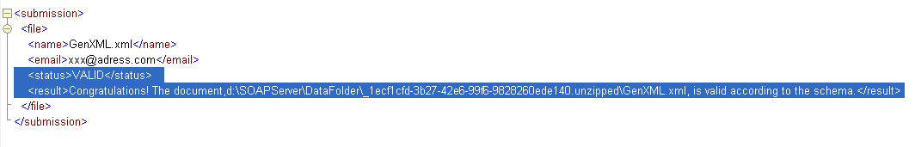
Figure 9: Example: Passed Schema Validation

- Failed Schema Validation:

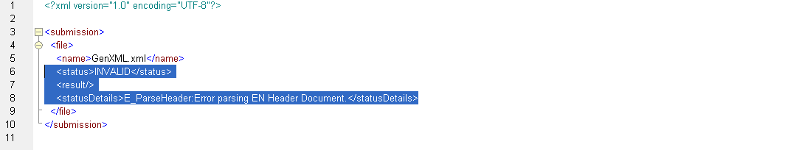
Figure 10: Example: Failed Schema Validation

- Passed Schema Validation, Error in Data:

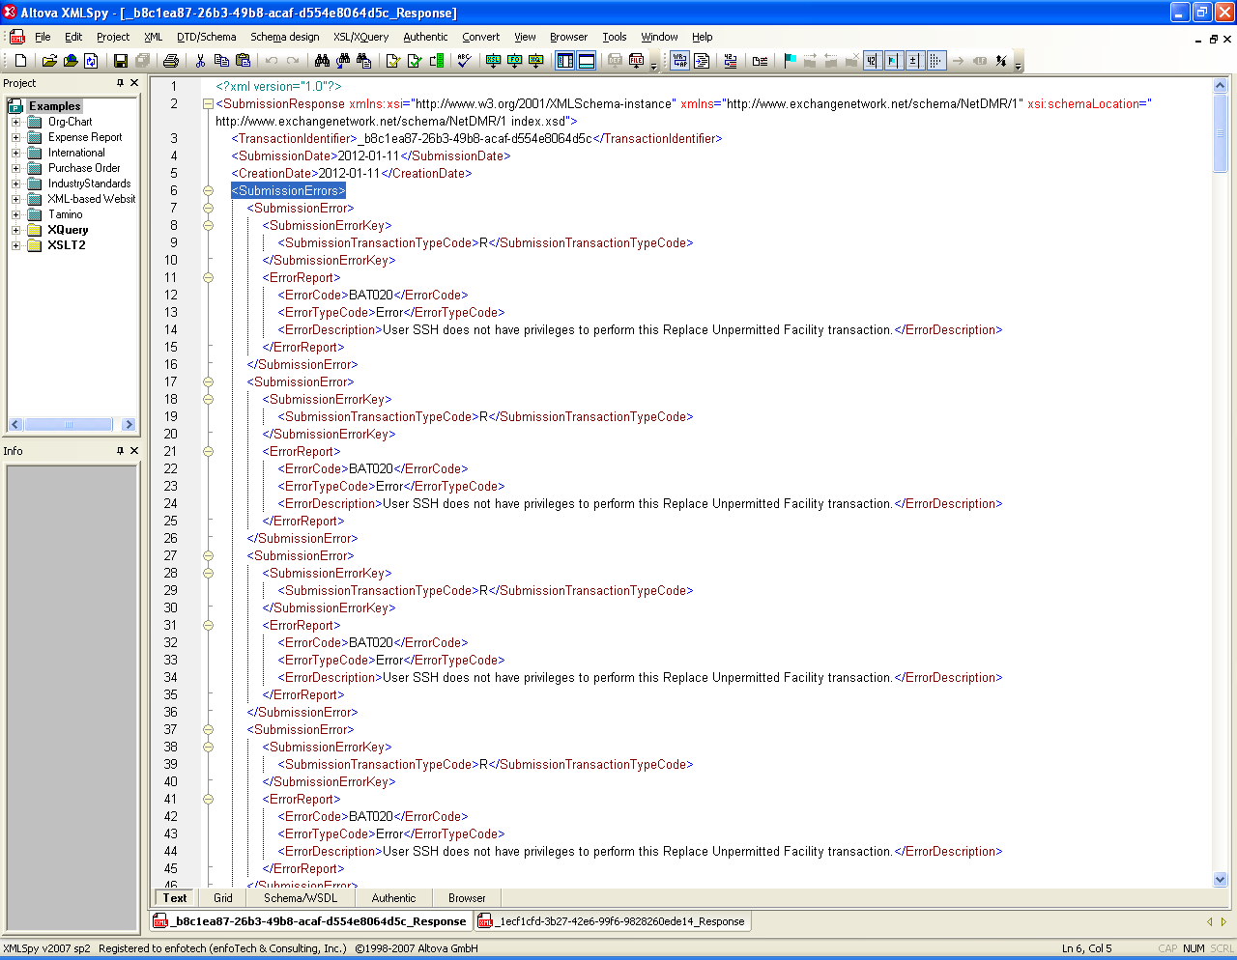
Figure 11: Example: Passed Schema Validation, Data Error

- Passed Schema Validation, No Error in Data:

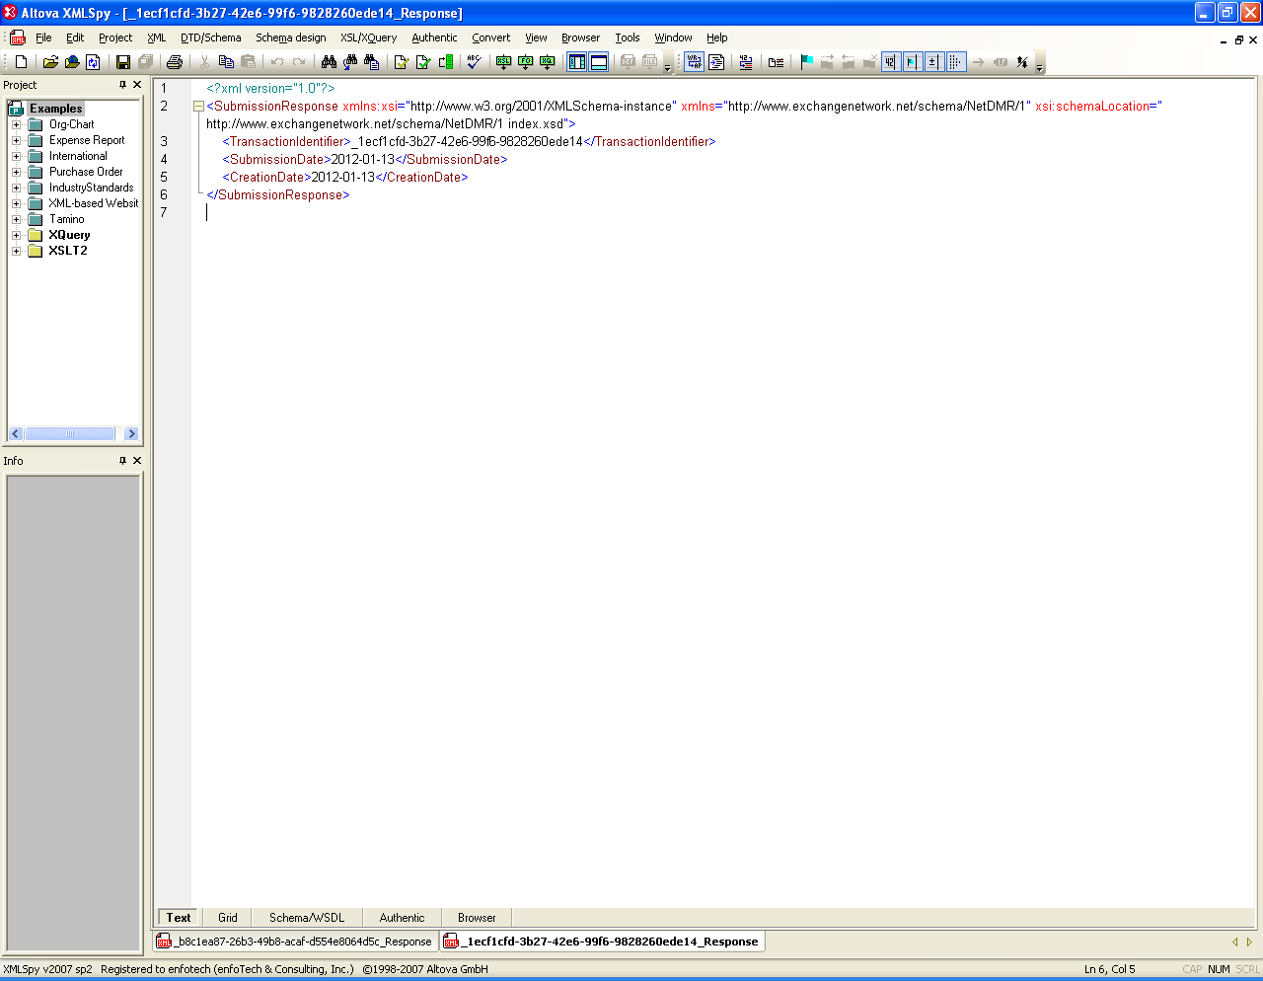
Figure 12: Example: Passed Schema Validation, No Data Error

